Partners Microsite

**Navigation:**

* Home
* Success Tips

* Partner rePortal Tutorial
* Helpful Links

**HOME PAGE**

Entrepreneurs Respectfully Serving Entrepreneurs

Heartland Partner Solutions is all about you, our partners. Your partnership with Heartland allows you to offer solutions tailored to meet your business customers’ individual needs. Be sure to bookmark this microsite as it contains information and links to all the items you will need:

* Tips for discovering and nurturing successful referrals.
* Tutorial on tracking your referrals.
* Links to marketing and developer materials.

We want to make sure you have everything you need to strengthen existing business relationships and gain new customers. Here’s to our successful partnership!

**SUCCESS TIPS**

**Conversation Starters**

Lead your customers into a conversation with your Heartland Relationship Manager (RM) by asking just a few simple questions.

**Suggested Questions for card customers**

* Who do you use for merchant services? - or - How are you currently accepting credit card payments?
* Does a local representative visit you onsite when needed?
* Are funds deposited the next day? If so, do the American Express and Discover funds also deposit the next day?
* How much time does it take for you to reconcile your batches with your bank deposits?
* What is your processor doing to ensure that your data and your customer’s data is secure?
* Do you accept payments online?
* Do you accept payments off-site?
* Are you leasing equipment? If so, is it month-to-month with no termination penalty?

**The Heartland Advantage for card customers**

* Heartland RMs live and work right here and provide excellent customer service.
* If a batch is closed by 8 p.m. EST, funds are deposited the next morning.
* There is only one deposit for all major card brands – including American Express and Discover – making it much easier to balance the books. Also, funds are received much faster than other processors.
* Heartland does not charge “junk fees” or hidden fees. Customers know exactly what they are paying and why, because Heartland statements clearly define every charge.
* Heartland does not arbitrarily increase pricing.
* Heartland does not trap merchants with oppressive leases for aging equipment.

Once your customer says they would like to know more, please send their contact information to your Heartland RM (Card) or SPA (Payroll), using the [rePortal](https://reports.heartlandpaymentsystems.com/).

**Suggested Questions for Payroll**

* How are you currently handling your payroll?
* Are you using an HR system to manage employees and ensure that you are in compliance?
* Do you offer direct deposit and/or payroll cards for your employees? Do you pay extra for those services?
* Are your employees able to access their information online?
* Do you have a compliant time and labor system?
* How do you handle your HR needs and questions?
* Do you have an employee handbook, and when was it last updated?
* How are you staying up to date with the ever-changing state and federal labor laws?
* Are you taking advantage of the tax credits available to you as an employer?

**The Heartland Advantage for Payroll customers**

* Heartland is a full-service payroll and HR provider and they are our partner of choice.
* Heartland’s philosophy is “Honesty, Fairness, and Transparency.”
* Our Heartland payroll representative is local and will provide ongoing service.
* Heartland does not arbitrarily increase pricing.
* Heartland has a simple pricing structure with no “nickel and dime” or hidden fees - customers will always know exactly what they are paying and why.
* Heartland offers a cloud-based application, providing easy access to tools, forms and reporting.
* Heartland supports small and medium-sized businesses by providing access to multiple HR generalists and attorneys to assist employers with questions and compliance.

Once your customer says they would like to know more, please send their contact information to your Heartland RM (Card) or SPA (Payroll) by entering it into the [rePortal](https://reports.heartlandpaymentsystems.com/).

**Referral Process Reminders**

* Speak with customers using the “Conversation Starter” talking points.
* Speak to the value of Heartland. Price should not be mentioned other than to say Heartland provides clear and transparent pricing, and the customer will know exactly what they are paying and to whom.
* Once the referral is entered into the rePortal, you can step back and let your Heartland partner take over the sales process from there! They will update you throughout the process and ask for assistance if needed.
* Your Heartland RM/SPA will have a pricing discussion with the customer. Please do not ask for a proposal or pricing comparison to give to the customer.
* If you would like to attend the meeting with Heartland, be sure to let your RM/SPA know, but always allow them to run the sales process. There are reasons for their methods.
* Questions that are not in direct support of the sale should only be asked after the meeting and away from the customer.
* Questions to your Heartland partners are welcome, but please remember that they are the merchant services/payroll experts, and YOU are the expert at your own business.

**PARTNER REPORTAL**

The Partner rePortal is a reporting tool that can help you track the results of referrals you submit, and compensation you receive from Heartland associated with your referrals. You and/or your employees should enter ALL your referrals directly into the rePortal. A step-by-step tutorial is outlined below. You can also **Download the PDF version [NEED TO CREATE A PDF VERSION].**

**This tutorial contains the following steps**

* **Logging In**
* **How to View Payments**
* **How to Submit/Track Referrals**

**Logging In**

Please follow the steps below to generate your login information:

1. Visit <https://reports.heartlandpaymentsystems.com/>
2. Click “Forgot Password” link under the Password field and enter your email address
3. Click “Reset”
4. You will receive an email from PartnerReporting@e-hps.com with a link to enter a new password. After setting up your new password, navigate back to <https://reports.heartlandpaymentsystems.com/> and log in.

**How to View Payments**

The Partner rePortal contains multiple dashboards designed for specific reporting needs. Dashboard navigation can be found across the top of the page.

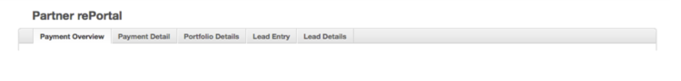

**Payment Overview Dashboard**

The total payment is broken down by product and affiliate code and is summarized at the top of the Payment Overview dashboard. Note: Payments are dispersed around the 22nd of the month following activity. For example, March activity is paid on approximately April 22nd.

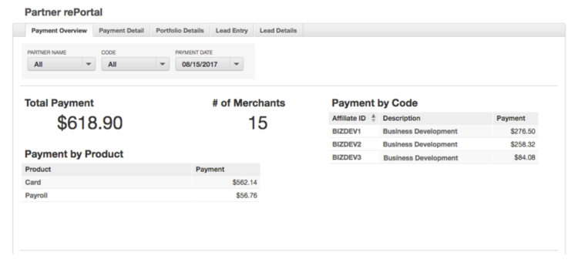

Graphs are available for visual representation on this dashboard. One graph shows the number of merchants and the payment amounts over time. Another shows the payment amount per state.

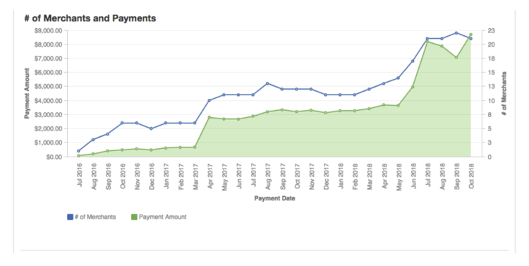

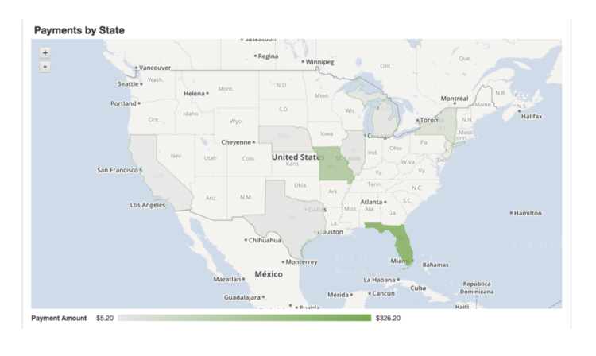

**Payment Details**

The Payment Details tab shows the breakdown of each of your payments by merchant and provides details on how each payment was calculated.

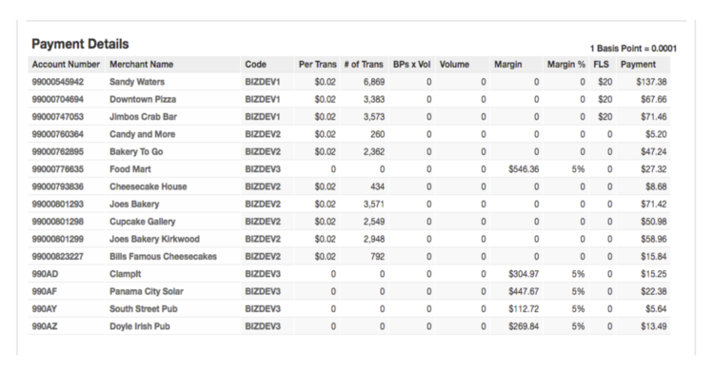

Click on a specific merchant or payment amount for additional details.

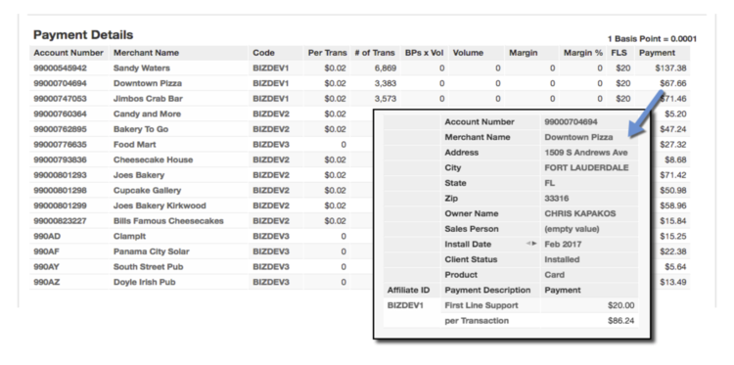

Please note:

The Payment Details report reflects only those merchants that generated a payment for that time period. If a merchant is missing from the report, there may not have been enough activity to generate a payment during that time period. All merchants can be found on the Portfolio Details dashboard, regardless of payment amount.

**Portfolio Details**

The Portfolio Details tab displays the lifetime payments summary information as well as the total number of merchant installs for the portfolio.

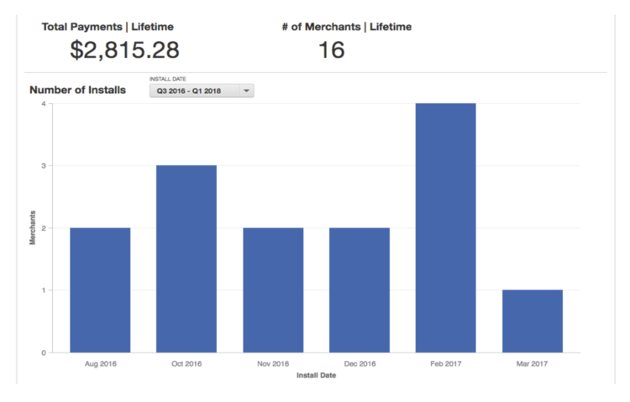

The Merchant Details report displays a list of all merchants and their total lifetime payment. Click on the payment total for historical details.

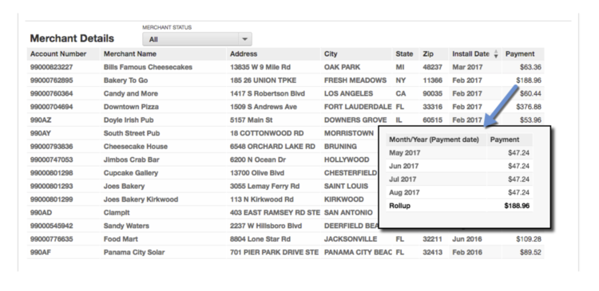

**Filters**

Select from the filter options available on each dashboard. Click apply to activate the filter.

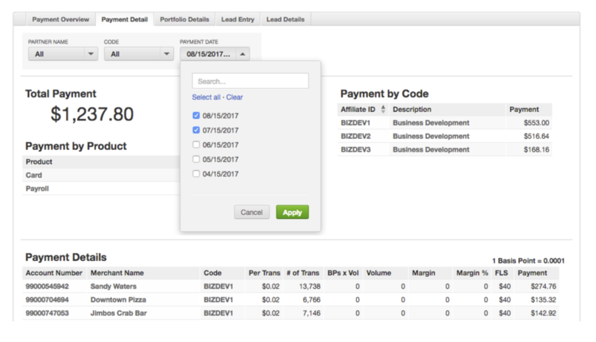

**Sorting**

Reports are sortable by clicking the ascending/descending arrows on a column header.

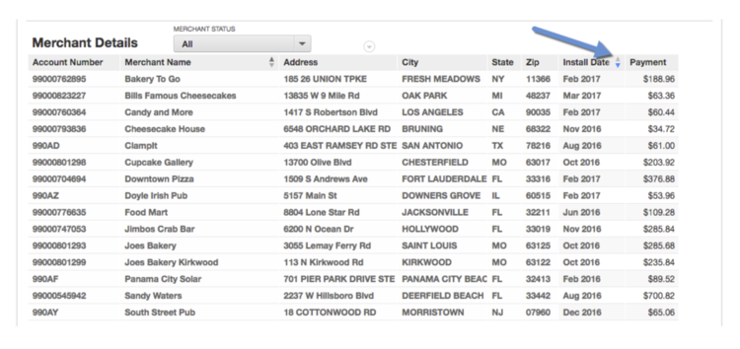

**Exporting**

Place your cursor over the report and select the arrow next to the report title, then choose Download As and select your preferred file format.

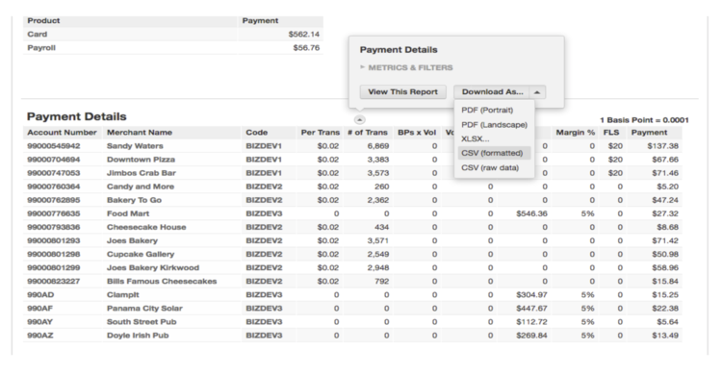

For assistance with the Partner rePortal, please reach out to your Heartland representative or email our Business Development Operations team at [bizdev@e-hps.com](mailto:bizdev@e-hps.com).

**How to Submit/Track Referrals**

**Lead Entry**

To enter a lead, navigate to the Lead Entry tab.

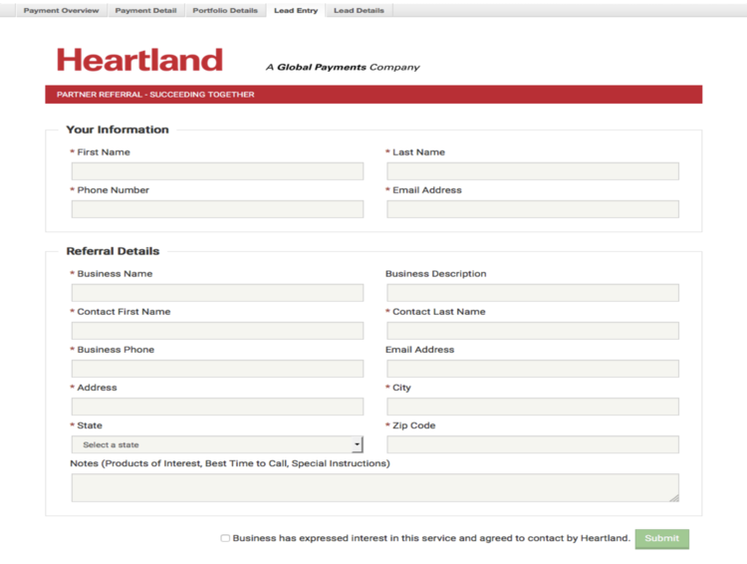

Fill out the top section entitled “Your Information” with your name and contact information.

Under the “Referral Details” section, fill in the information of the business you are referring to Heartland. Don’t forget to check the box that states that the business you are submitting has expressed interest and has agreed to be contacted by Heartland.

Click the Submit button. Once submitted, the referral lead is automatically routed to your Relationship Manager and they will contact the business. You will be able to follow the activity of your lead in your Lead List found under the “Lead Details” tab.

**Lead Details**

The “Lead Details” tab displays your Lead List. It shows the date the lead was entered, the business name, status of the lead, the effective date of that status, the name of whom the lead was submitted by, what code it is attached to, and the Heartland Sales Person working the lead. It can be sorted by Lead Date, Status, Submitted By and Code.

Please note:

Lead details are uploaded nightly. Once a lead is entered, it will appear on the lead details dashboard the next day. Any status changes to your leads will also be part of the nightly upload and will be viewable the next day.

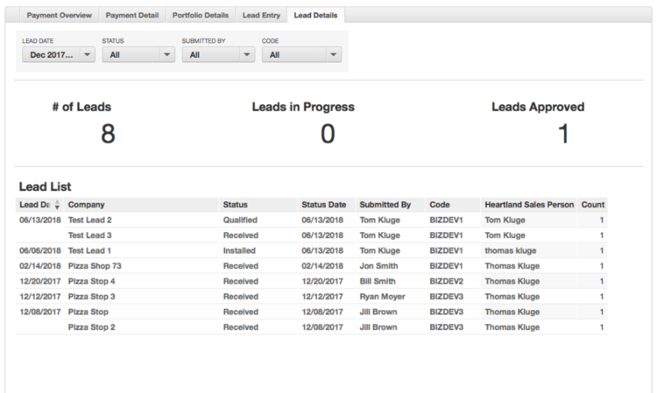

You can edit the Lead Date column to view a particular date or date range.

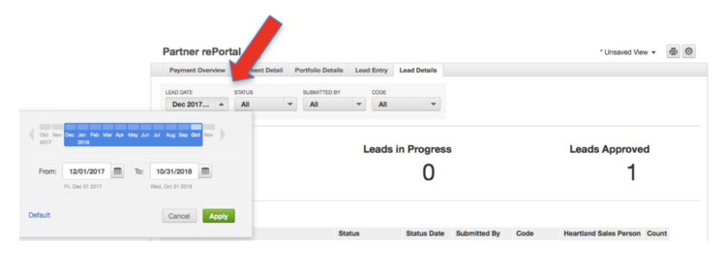

**Lead Status**

Each lead will have one of the listed statuses below:

|  |  |
| --- | --- |
| **rePortal Status** | **Definition** |
| Received | Your referral/lead has been routed to your Heartland partner (RM or SPA) and is awaiting their acceptance. |
| Contacting | Your referral/lead has been accepted by your Heartland Partner (RM or SPA) and they are actively trying to reach the prospect. |
| Appointment | Your Heartland partner (RM or SPA) has successfully reached the prospect and has scheduled an appointment to meet with the prospect. |
| Qualified | Your Heartland partner (RM or SPA) has qualified the prospect, entered initial numbers, and is creating a pricing model/proposal for the prospect. |
| InProgress-Pricing | Your Heartland Relationship Manager has created a pricing model for presentation to the prospect (either waiting to present or actively negotiating). |
| InProgress-Contract | Your Heartland Relationship Manager is actively completing the merchant application. |
| Submitted | Your Heartland Relationship Manager has submitted the merchant application for underwriting approval, enrollment, equipment shipping and installation. |
| Installed | Merchant is actively processing with Heartland and has submitted their first “batch” of transactions for payment. |
| Terminated | A shared customer has terminated their agreement with Heartland. (Note: the Status Date will not be updated with the date the account terminated, so terminated accounts will keep their “Installed” date as a final status date.) |
| Lost | Your Heartland partner (RM or SPA) has determined this opportunity is no longer open for possible sale/install. |

**Exporting Reports**

Place your cursor over the report and select the arrow next to the report title, then choose Download As and select your preferred file format.

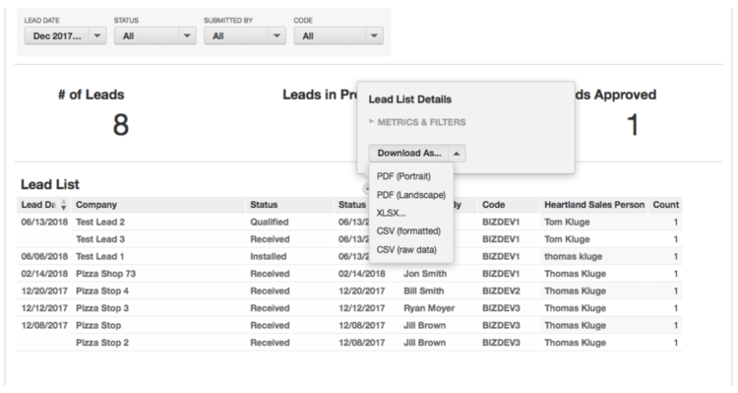

For assistance with reports, please contact the Heartland Business Development team at [bizdev@e-hps.com](mailto:bizdev@e-hps.com).

**HELPFUL LINKS**

**Partner rePortal**

Our Partner reporting tool that helps you analyze and track the status and compensation related to your Heartland referrals. If you are new to a Heartland partnership, be sure to check out the rePortal Tutorial for a step-by-step guide to accessing and navigating the Partner rePortal.

[rePortal Login](https://reports.heartlandpaymentsystems.com)

**Partner Marketing Resources**

You can select and order co-branded print materials with your logo, and/or download free digital marketing collateral about Heartland products, services, and solutions. You'll find email content, web and social media assets, product sell sheets, brochures, images, logos, and more on the Partner Marketing Resources site.

[Get marketing materials](https://partnerresources.heartland.us/b2b_login.aspx)

**Integrated Partners**

Looking for SDKs, APIs, certification information or developer support? Integrated Partners can log into the Developer Portal for all of these and more.

[Developer Portal](https://developer.heartlandpaymentsystems.com/Account/SignIn)